PROGRAMMING

FUNDAMENTALS

Semester

Project



**Programming Fundamentals**

# SEMESTER PROJECT

C++ MANAGEMENT SYSTEM

INTRODUCTION:

This management system tells the GPA of student by getting some information about the student. It could calculate the GPA of student of any department and any semester through a formula and through getting information. The information it requires to calculate GPA, mainly is marks of student in different courses and their credit hours. If user wants to calculate the GPA of more than one student so we will press 1 so that to continue the loop, enter the record of another student and to exit from loop we will press any number other than 1. Not only the GPA is calculated but also the information that user entered and GPA is stored in files. We enter all the detail i.e., department name, section, semester and all the other headings only first time when we run the code after that we fill comment all such type of lines so that these information do not store in our files again and again when we enter more data. We can also enter and store data of more students in files.

CODE:

#include<iostream>

#include<fstream>

#include<cstring>

using namespace std;

struct student_GPA

{

string name,roll_no,department;

char section;

int semester;

int no_of_courses;

float GPA,sum;

int total_credithours;

float SGPA;

string grade;

}s1;

void Keep_record();

main()

{

int check;

cout<<"\t GPA MANAGEMENT SYSTEM OF FJWU"<<endl;

cout<<"Department : ";

getline(cin,s1.department);

cout<<"Semester : ";

cin>>s1.semester;

cout<<"Section : ";

cin>>s1.section;

cout<<"No. of courses : ";

cin>>s1.no_of_courses;

cout<<"Enter the following information for student's GPA record."<<endl;

do

{

Keep_record();

cout<<"Do you want to find the GPA of another student. "<<endl;

cout<<"If yes then press 1 to enter the record of student."<<endl;

cout<<"If no then press any number other than 1 "<<endl;

cin>>check;

}

while(check==1);

}

void Keep_record()

{

float marks[s1.no_of_courses];

int credit_hours[s1.no_of_courses];

fstream file;

file.open("D:student_GPA_file.txt",ios::app);

if(file.is_open())

{

cout<<"Student ";

getline(cin,s1.name);

cout<<" Name : ";

getline(cin,s1.name);

cout<<"Roll no. : ";

getline(cin,s1.roll_no);

s1.sum=0;

s1.total_credithours=0;

int i=1;

file<<"\t\t\t"<<"GPA MANAGEMENT SYSTEM OF FATIMA JINNAH WOMEN UNUVERSITY"<<"\n";

file<<"\t\t\t"<<"Resut of "<<s1.department<<" Department"<<"\n";

file<<"\tDEPARTMENT:-\t"<<s1.department<<"\n";

file<<"\tSECTION:-\t"<<s1.section<<"\n";

file<<"\tSEMISTER:-\t"<<s1.semester<<"\n";

file<<"\tNO.OF COURSES:-\t"<<s1.no_of_courses<<"\n";

file<<"STUDENT NAME\t"<<" ROLL NO.\t";

for(int i=1;i<=s1.no_of_courses;i++)

{

file<<"Grade in course "<<i<<"\t";

}

file<<"\tSGPA"<<"\n";

file<<s1.name<<"\t"<<s1.roll_no<<"\t\t";

for(int i=1;i<=s1.no_of_courses;i++)

{

cout<<"Marks of student in course "<<i<<" : ",

cin>>marks[i];

cout<<"Credit hours of course "<<i<<" : ";

cin>>credit_hours[i];

if(marks[i]>=85)

{

cout<<"Grade of student in course "<<i<<" : "<<"A"<<endl;

s1.GPA=4.00*credit_hours[i];

s1.grade="A";

}

if((marks[i]<=84)&&(marks[i]>=80))

{

cout<<"Grade of student in course "<<i<<" : "<<"A-"<<endl;

s1.GPA=3.70*credit_hours[i];

s1.grade="A-";

}

if((marks[i]<=79)&&(marks[i]>=75))

{

cout<<"Grade of student in course "<<i<<" : "<<"B+"<<endl;

s1.GPA=3.30*credit_hours[i];

s1.grade="B+";

}

if((marks[i]<=74)&&(marks[i]>=70))

{

cout<<"Grade of student in course "<<i<<" : "<<"B"<<endl;

s1.GPA=3.00*credit_hours[i];

s1.grade="B";

}

if((marks[i]<=69)&&(marks[i]>=65))

{

cout<<"Grade of student in course "<<i<<" : "<<"B-"<<endl;

s1.GPA=2.70*credit_hours[i];

s1.grade="B-";

}

if((marks[i]<=64)&&(marks[i]>=61))

{

cout<<"Grade of student in course "<<i<<" : "<<"C+"<<endl;

s1.GPA=2.30*credit_hours[i];

s1.grade="C+";

}

if((marks[i]<=60)&&(marks[i]>=58))

{

cout<<"Grade of student in course "<<i<<" : "<<"C"<<endl;

s1.GPA=2.00*credit_hours[i];

s1.grade="C";

}

if((marks[i]<=57)&&(marks[i]>=55))

 {

cout<<"Grade of student in course "<<i<<" : "<<"C-"<<endl;

s1.GPA=1.70*credit_hours[i];

s1.grade="C-";

}

if((marks[i]<=54)&&(marks[i]>=50))

{

cout<<"Grade of student in course "<<i<<" : "<<"D"<<endl;

s1.GPA=1.00*credit_hours[i];

s1.grade="D";

 }

if(marks[i]<50)

{

cout<<"Grade of student in course "<<i<<" : "<<"F"<<endl;

s1.GPA=0.00*credit_hours[i];

s1.grade="F";

}

file<<s1.grade<<"\t\t\t";

s1.sum=s1.sum+s1.GPA;

 s1.total_credithours=s1.total_credithours+credit_hours[i];

}

s1.SGPA=(s1.sum/s1.total_credithours);

cout<<"Your GPA of semester "<<s1.semester<<" is "<<s1.SGPA<<endl;

file<<s1.SGPA<<"\n";

}

else

{

cout<<"File not found"<<endl;

}

}

FEW CONSLE OUTPUTS:

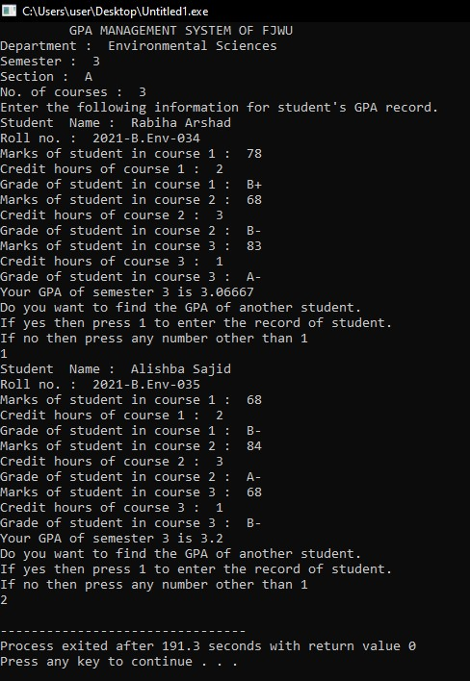

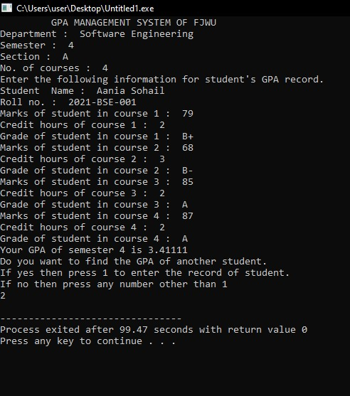

# THE END